Database Created :

Database Name-porductapp

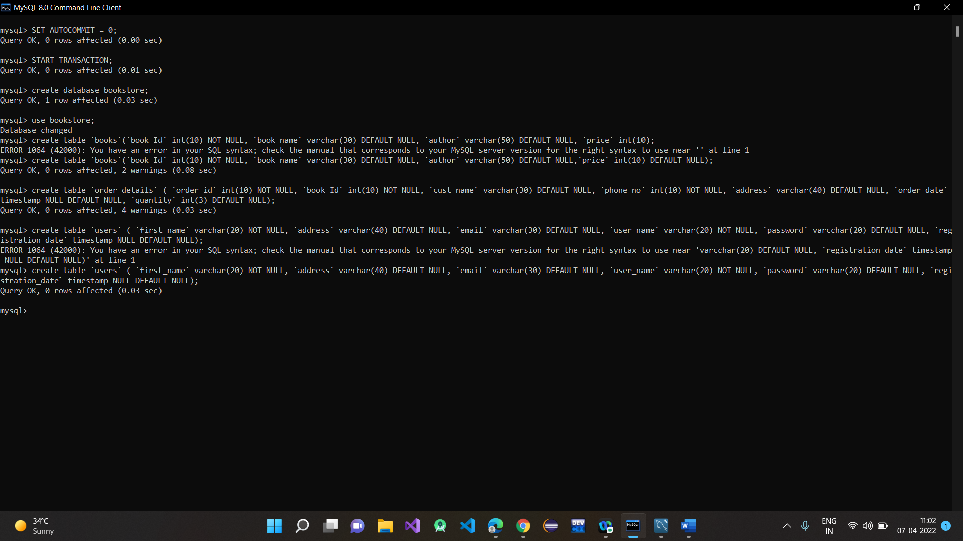

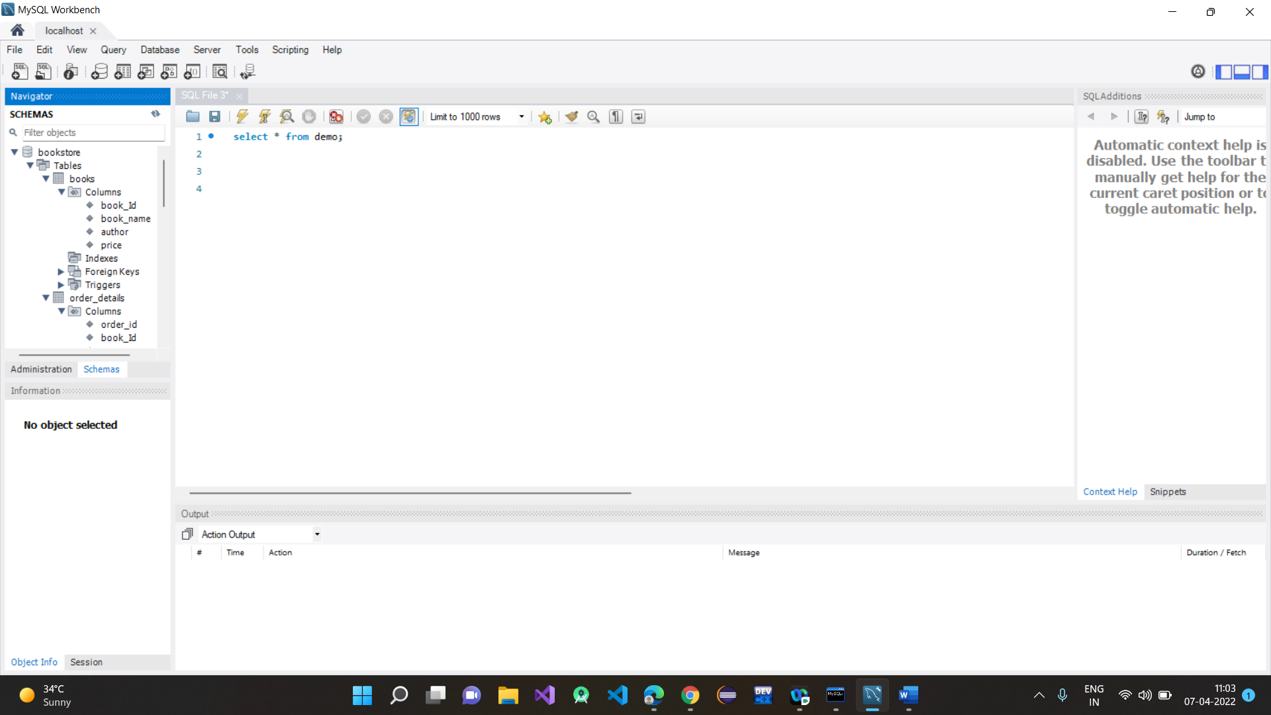

**Book table :**

create table Books (Book_Id int NOT NULL AUTO_INCREMENT, Book_Name varchar(80),

Author varchar(50),Price float,primary key(Book_Id));

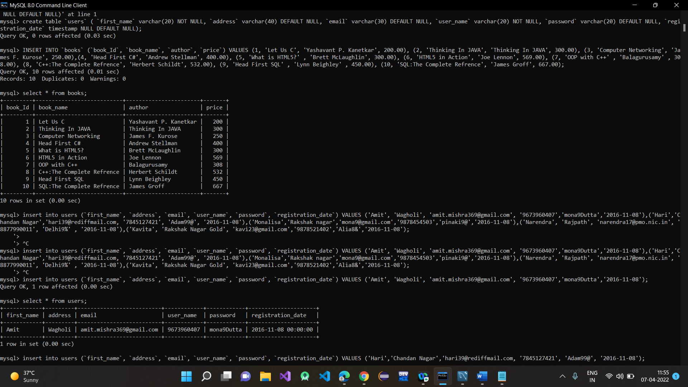

**User Table :**

create table Users (first_name varchar(20), address varchar(20), email varchar(30), user_name varchar(20), password varchar(20), registration_date varchar(20));

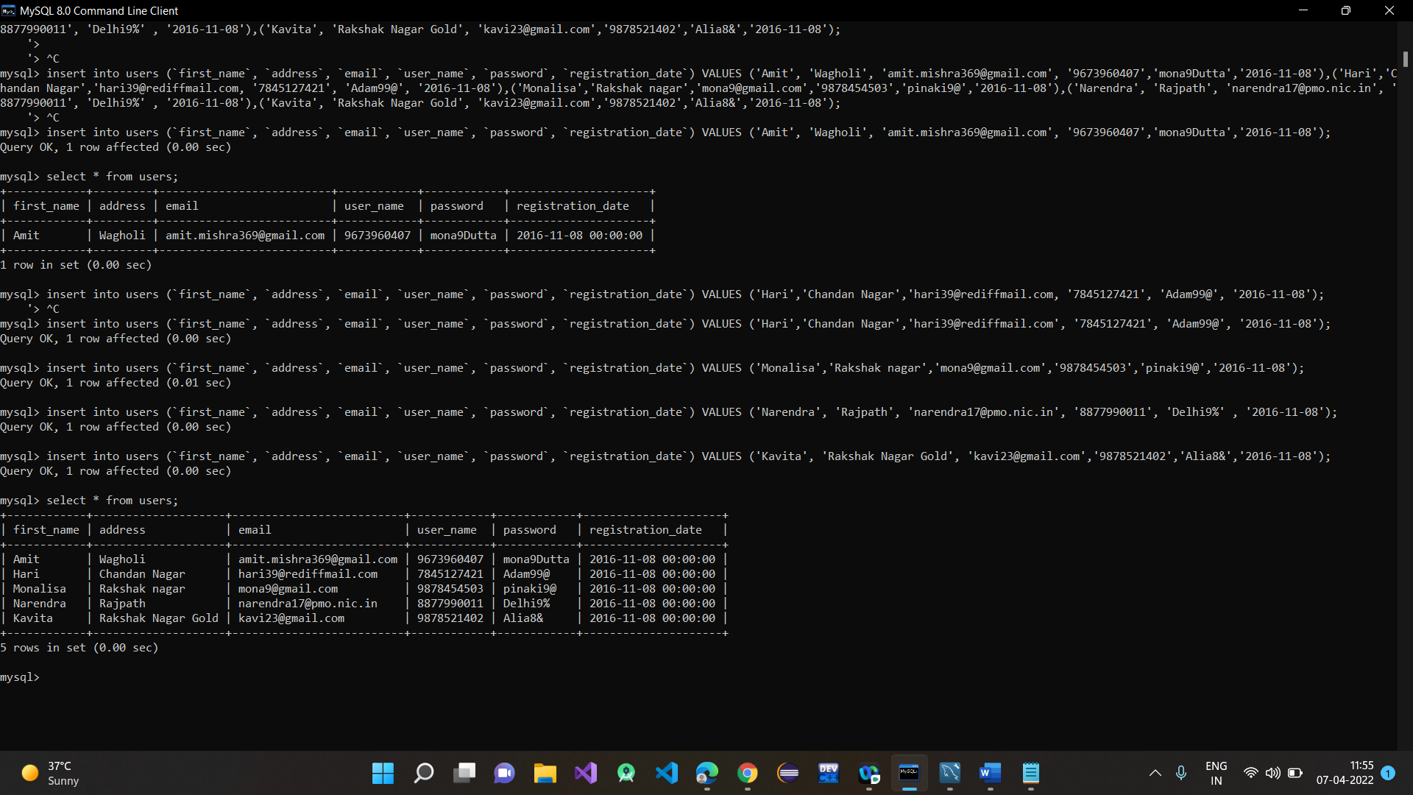

**Order_details :**

create table Order_Details (Order_Id int NOT NULL AUTO_INCREMENT, Book_Id int, Cust_Name varchar(50), Phone_No int, Address varchar(40), Order_Date varchar(30),

Quantity varchar(30), CONSTRAINT fk_book FOREIGN KEY (Book_Id) REFERENCES Books(Book_Id),primary key (Order_Id));

